Thanks very much for purchasing cutting plotter.
- For ensuring you to make best use of the machine, please read this manual carefully and thoroughly before you starting to use the machine.
- Please turn off the power quickly if you encounter any problems, and refer to this manual or contact your dealer.

Special Declaration
  - Manufacturer keeps the right of changing product specification without prior notice;
  - Manufacturer only takes the legal duty of product itself, not undertaking any other loss produced after product was wrong;

Contents
Chap1. Attention ------------------------------------------------- (4)
Chap2. Basic operation -------------------------------------------- (4)
2-1 Packing box------------------------------------------------(4)
2-2 Accessories-------------------------------------------------(5)
2-3 Installation and connection-------------------------------(5)
2-4 Installation of tools----------------------------------------(5)
2-5 Parts of stand-----------------------------------------------(7)
Chap.3 Operation instruction (Luxurious type)------------------(8)
3-1 Item of the component------------------------------------(8)
3-2 Assembly of machine stand------------------------------(9)
3-3 Control Panel --------------------------------------------(10)
3-4 Basic Operation------------------------------------------(10)
3-5 Operating instruction------------------------------------(13)
Chap.4 Operation instruction (Practical type)------------------(17)
4-1 Item of the component----------------------------------(17)
4-2 Assembly of machine stand----------------------------(17)
4-3 Control Panel --------------------------------------------(18)
4-4 Basic Operation------------------------------------------(19)
4-5 Operating instruction------------------------------------(21)
Chap. 5 Parameters Table------------------------------------------(25)
Chap. 6 USB Port Setting -----------------------------------------(26)
6-1 Install USB port(USCutter USB Driver)-------------(26)
6-2 Port Setting-----------------------------------------------(27)
6-3. Software--------------------------------------------------(27)
Chap. 7 Troubleshooting-------------------------------------------(33)

\

Chap. 1 Attention
Please read the attention carefully before operating the machine.
- No magnetic devices should be placed in the vicinity of the plotter, specifically the carriage.
- Prevent from dropping foreign matters into cracks such as pins, little screws, etc.
- Please pull out the power plug if not using during a long time.
- Don’t plug or unplug serial/parallel/usb cables on plotter while the power is on
- Don’t leave pinch rollers pressed down while machine is not in use.
- Always connect the power cord to a grounded outlet.
- Don’t move the carriage manually.
- Don’t touch carriage, metal roller, cutter and all moving devices when the machine is working.
- Place machine in a stable area that is free of strong vibrations, electromagnetic field, dust, moisture and /or direct sunlight.
- Don’t press top beam or lift up black rail.

Chap. 2 Basic operation
2-1 Packing-box
Please carefully check up the goods after opening the packing box, and in every box there should be as following:
- A main machine.
- A packet of accessories.
- A set of parts of machine stand.

2-2 Accessories
NO. | Item | Quantity
1 | Power cord | 1
2 | Operation manual | 1
3 | Cutter holder | 1
4 | Cutter | 3
5 | Plotter holder | 1
6 | Allen wrench | 1
7 | Serial cable | 1
8 | Parallel cable(optional) | 1
9 | USB cable (optional) | 1
10 | Plotter protective cover | 1
11 | Driver disk for CorelDraw and USB port | 1
12 | Artcut 2009 CD (optional) | 1
2-3 Installation and connection
1 Place the machine in a plane and roomy place
2 Connect the signal cable to the COM1,COM2 /USB port of the computer
3 Check voltage of the power source and whether it is grounded, do not connect the power utill all are in a good condition

2-4 Installation of tools
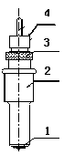2-4.1 Structure of cutter holder and items of components
Rotate the cutter ajusting screw to adjust the out-stretching length of the cutter as to ensure that it doesn’t cut off the bottom layer of stickiness.
- Cutter (diameter is 2mm)
- Cutter holder shell
- Cutter ajusting screw
- Cutter holder body
2-4.2 Installation and adjustment of blade
1.Before installing the cutter, you must carefully clean the cutter holder body, the cutter and your hands. Even very slight dirt can affect the performance of the cutter. Use a flexible plastic or rubber grip to hold the blade in your hand. Carefully insert the blade into the cutter holder body and it should magnetically attach.

2 Rotate the shell of the cutter holder and make the out-stretching length of the blade tip not longer than the thickness of the sticker

3. Don't touch the blade top with your finger to prevent injury
2-4.3 Structure of Plotter holder and items of components
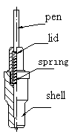Fit the the ball pen into the plotter holder, the structure is as
shows in the following drawing .
- Rotate the lid.
- Insert a ballpoint pen and let the pen tip out of proper length.
- Cover the pen with the lid then rotate them into the shell

2-4.4 Installation
1. Turn off the power
2. Loosen the locking screw of the tool carrier, then put the cutter holder or plotter holder in the tool carrier When the tool are in appropriate position, fasten the locking screw clockwise at last.

2-4.5 Using life of the cutter
Cutter’s using life is limited, but you can use it as long as possible.
Note:
1. More longer the out-stretching length of the cutter, more shorter the using life. Please avoid cutting off the bottom layer during the process of cutting.
2. The more cutting press, the shorter the using life.
3. As for different materials, the requirement to the cutter sharpness is different.
4. Set the cutting press as little as possible; only increase it when the cutter feels blunt.
5. As for the cutters from different factories, the using life is also very different.
6. Renew the cutter timely when it is blunt in case of affecting the machine performance. As an urgent method, a piece of leather can be used to sharpen the blade tip just like sharpening a razor.

2-5 Parts of stand
(Luxurious type)
NO. | Item | Quantity | NO. | Item | Quantity
1 | Left column | 1 | 8 | Connection board | 2
2 | Right column | 1 | 9 | Screw M4×20 | 10/12
3 | Crossbeam | 1 | 10 | Screw M4×8 | 8
4 | Pillar-bars | 2 | 11 | Vinyl basket (optional) | 1
5 | Pillars/wheels | 4 | 12 | Basket rail (optional) | 2
6 | Paper roller | 2 | 13 | Slide (optional) | 2
7 | Paper hanger | 2
(Practical type)
NO. | Item | Quantity | NO. | Item | Quantity
1 | Left column | 1 | 6 | Paper roller | 2
2 | Right column | 1 | 7 | Paper hanger | 2
3 | Crossbeam | 1 | 8 | Connection board | 2
4 | Pillar-bars | 2 | 9 | Screw M4×20 | 10/12
5 | Pillars/wheels | 4 | 10 | Screw M4×8 | 8

Chap.3 Operating Instruction (Luxurious type)
3-1 Item of the component

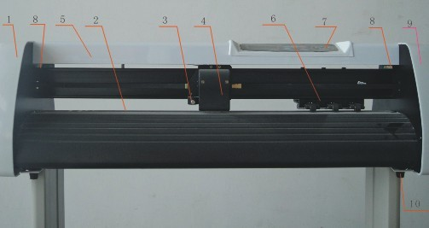
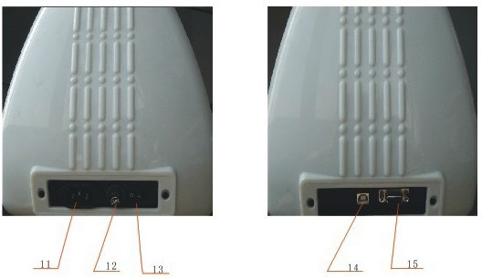

1. Left cover 9. Right cover
2. Metal roller 10. Pillar
3. Cutter holder 11. Power socket
4. Carriage 12. Fuse socket
5. Cover of guide 13. Power switch
6. Pinch roller 14 .USB to serial adapter port (optional)
7. Controlling panel 15. Serial port
8. Position setting knob

3-2 Assembly of machine stand
Referring to the following drawing:
（Available to the type with minimum width 780mm only）

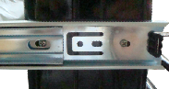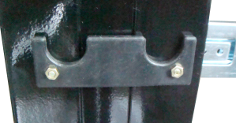
slide rail
vinyl basket
basket rail （long）
Connection board
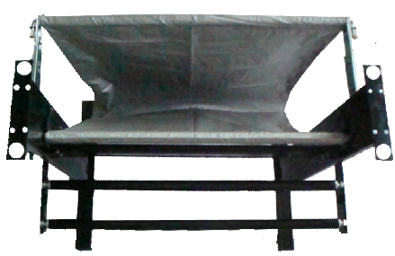
Pillar bar
Right column
Crossbeam

Vinyl hanger
Pillar wheel
Vinyl hanger
Left column
basket rail （short）

Assemble Step:
Step 1: Connect the pillar bars to left and right columns with screws respectively.
Step 2: Connect the crossbeam to left and right columns with screws.
Step 3: Join the paper hanger to the inside of the left and right columns with screws.
Step 4: join the slide rail to the left and right colums, and put the vinyl basket rail on the slide rail ( attn: basket rail is different)
Step 5: Join the connection board to the top of the left and right columns with screws.
Step 6: Lay down the four pillars of main machine, place the machine on the connection board, and then insert the pillars into the connection board to connect to the main machine.
Step 7:Place the paper-roller on the roller of paper hanger.

3-3 Control Panel
_1 Type
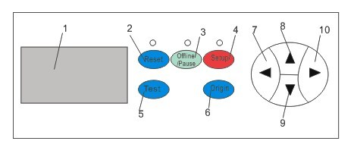

1. LCD display 6. origin setting button
2. Reset 7. Press +
3. Offline / Pause 8.Value +
4. Setup 9.Value -
5. Test 10. Press -

3-4 Basic Operation
3-4.1 Turn on the machine
1. . Check whether the power is in OFF position
2.. Plug the power cable into the power socket of the machine, and then press the switch on / off on the left
3. LCD in the control panel is on and displays the initializing process and shows following information

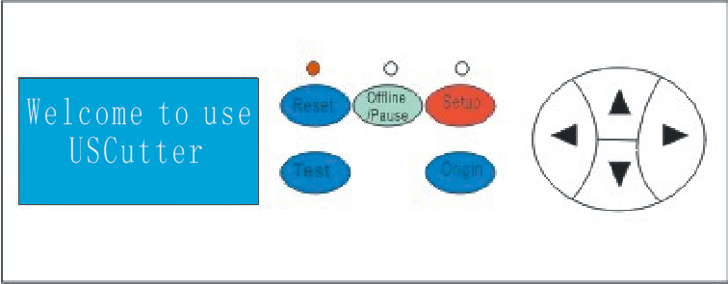

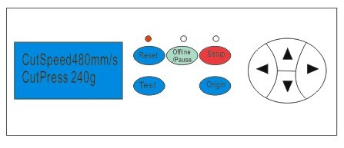

4 When the initializing is over, the red light is on, the machine is in online state and connectable with the computer to be operable

3-4.2 Installation of the cutting media
1 Loading the cutting media
1. Lift the pinch-roller handles and let it away from the metal rollers.
2. Insert the vinyl between metal rollers and pinch rollers of the machine from behind to front.
3. Carefully check the vinyl before cutting, since if vinyl is not well placed, serious deviation will occur. If the vinyl is uneven lift the pinch rollers on one side to adjust and then press down pinch rollers. It is necessary to trial-run the vinyl several times to attain minimum deviation before cutting work.

2 Adjust the place of pinch rollers according to paper width
Cutting plotter has 2 to 4 pinch rollers and they can be moved along the guide rail. The handles of pinch rollers must be lifted before moving pinch rollers, hold the back of the roller and push it to the left or the right. Please don’t pull the roller bars in the front, otherwise the machine precision will be affected.

3 The place of the rollers must be ensured:
1.Pinch rollers should be in the place out of the scope of the pattern.
2.Pinch rollers should be 10 to 50mm away from the edges of the paper.
3.Pinch rollers shouldn’t be let down on the conjunction of two connecting metal rollers.

3.4.3 Trial run (adjusting the press and tool)
1 Test Cut
Once the blade/plotter is installed and the vinyl is inserted, preliminary test-cut should be carried out to check the press of the blade/plotter if it is acceptable. To do so, press the TEST key. and shows as following. Then the machine will automatically cut a pattern

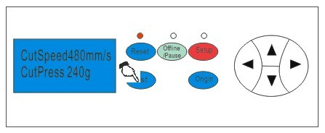

2 Press Adjustment
Take off the cutted pattern, if you fail, the pattern need to be further cut, because the press is too low or the protruding length of the blade top is too short . If the base paper is pierced through, it signifies that the protruding length of the blade top is too long and the press is too big. The protruding portion of the blade tip should be about 0.5mm or less in length normally which is 2/3 of the thickness of vinyl. Adjust the protruding length of the blade top and press according to result of test
By pressing F+ or F- the press of the blade will be increased or decreased by one level..

Caution:
Whenever you try a new type of vinyl, please check the cutting press by making a test cut.

3-5 Operating instruction
3-5.1 Reset
When the power is turned on, the machine can automatically reset.. the red light is on and the machine is ready to receive the data from the computer. As this point the LCD shows as following

The default setting is as following :
·Baud rate: 9600
·Cutting speed: 480mm/s
·Cutting press: 240g
·Cutting origin is according to the default of the machine
The above information may be changed during operation.
When it is working, if the RESET key is pressed, the machine will cancel the current job and return to default settings
3-5.2 Online
After the machine is reset, the red light (reset indicator) should be on. When the machine receives date from the computer, it is in online mode.
In this moment you can change the cutting speed by pressing V+ or V-
adjust the cutting press by pressing F+ or F

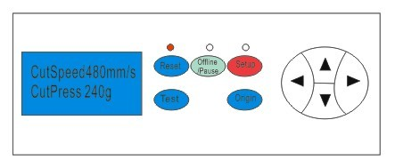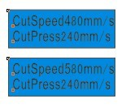

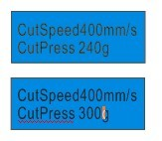
3-5.3 Offline /Pause
Press the OFFLINE key to enter offline mode. The yellow light is on. Meanwhile, “Motion, X= xxx, Y= yyy” will appear on LCD, which shows the coordinates location of the blade at the moment.

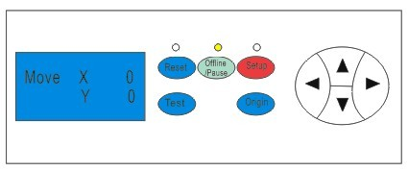

Press the key V+ or V- the carriage can be moved left or right. Press the key F+ or F- the vinyl can be moved forward or backward, In this state you you can move the blade top to the starting position. the step value of “X, Y” in the LCD will change accordingly

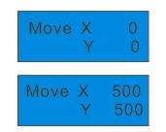

When it is working you press the Pause Key, the machine will stop working and if you press again the machine will cantinue working

3-5.4 Setting origin of plotting
When move the blade top to the starting position, press the Origin button the setting of the new origin is completed, The machine will start plotting from the new origin.
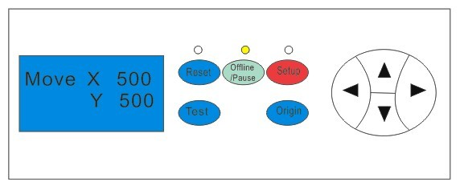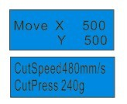
3-5.5 Setup
In ONLINE status, when you press the SETUP key, the green light is on, and the baud rate of serial port can be changed. If you press SETUP key again, it will restore to online status.
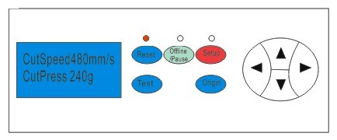

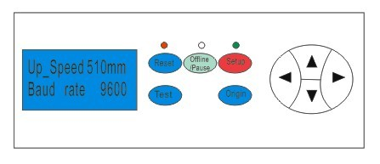

Chap.4 Operating Instruction (Practical type)
4-1 Item of the component
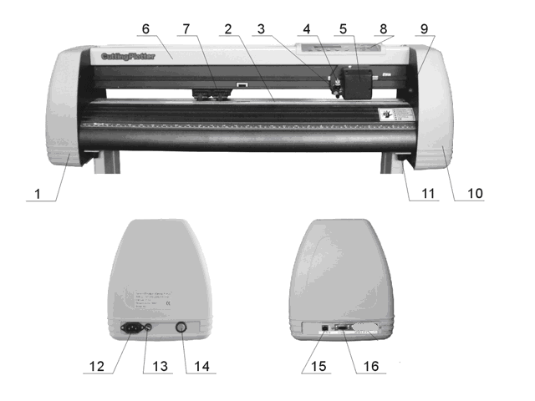

1. Left cover 10. Right cover
2. Metal roller 11. Pillar
3. Cutter bracket 12. Power socket
4. Cutter holder 13. Fuse socket
5. Carriage 14. Power switch
6. Cover of guide 15 .USB to serial adapter port (optional)
7. Pinch roller 16. Serial port
8. Controlling panel 9. Position setting knob

4-2 Assembly of machine stand
Referring to the following drawing:
（Available to the type with minimum width 780mm only）
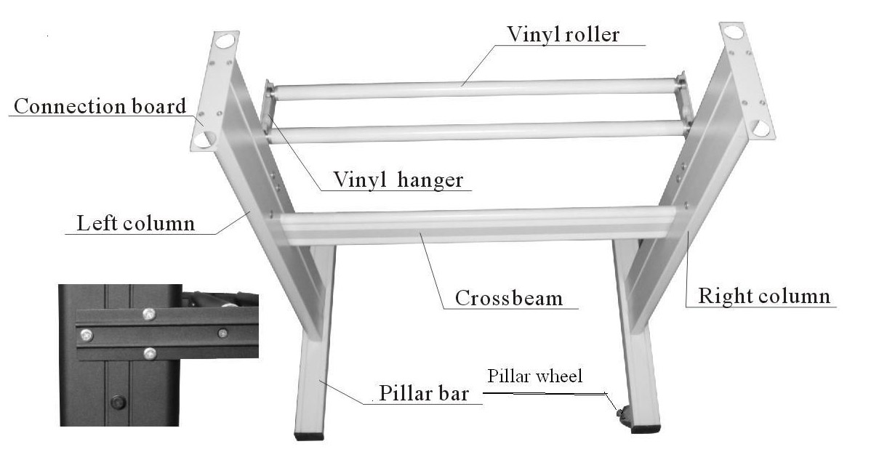
Step 1: Connect the pillar bars to left and right columns with screws respectively.
Step 2: Connect the crossbeam to left and right columns with screws.
Step 3: Join the paper hanger to the inside of the left and right columns with screws.
Step 4: Join the connection board to the top of the left and right columns with screws.
Step 5: Lay down the four pillars of main machine, place the machine on the connection board, and then insert the pillars into the connection board to connect to the main machine.
Step 6: Place the paper-roller on the roller of paper hanger.
  - Control Panel
4-3.1 Type
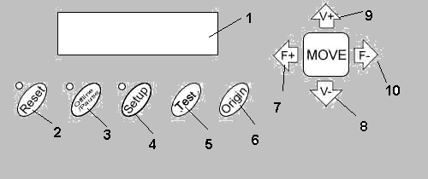

1. LCD display 6. origin setting button
2. Reset 7. Press +
3. Offline / Pause 8.Value –
4. Setup 9.Value +
5. Test 10. Press –

4-4 Basic Operation
4-4.1 Turn on the machine
1. . Check whether the power is in OFF position
2.. Plug the power cable into the power socket of the machine, and then press the switch on / off on the left
3. LCD in the control panel is on and displays the initializing process and shows following information
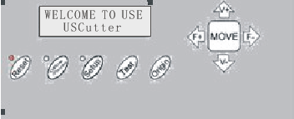

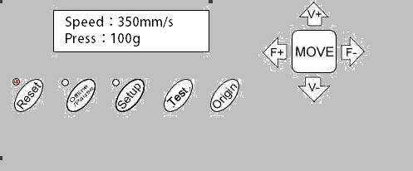

4 When the initializing is over, the red light is on, the machine is in online state and connectable with the computer to be operable

4-4.2 Installation of the cutting media
1 Loading the cutting media
1. Lift the pinch-roller handles and let it away from the metal rollers.
2. Insert the vinyl between metal rollers and pinch rollers of the machine from behind to front.
3. Carefully check the vinyl before cutting, since if vinyl is not well placed, serious deviation will occur. If the vinyl is uneven lift the pinch rollers on one side to adjust and then press down pinch rollers. It is necessary to trial-run the vinyl several times to attain minimum deviation before cutting work.

2 Adjust the place of pinch rollers according to paper width
Cutting plotter has 2 to 4 pinch rollers and they can be moved along the guide rail. The handles of pinch rollers must be lifted before moving pinch rollers, hold the back of the roller and push it to the left or the right. Please don’t pull the roller bars in the front, otherwise the machine precision will be affected.

3 The place of the rollers must ensure:
1.Pinch rollers should be in the place out of the scope of the pattern.
2.Pinch rollers should be 10 to 50mm away from the edges of the paper.
3.Pinch rollers shouldn’t be let down on the conjunction of two connecting metal rollers.
4.4.3 Trial run (adjusting the press and tool)
1 Test Cut
Once the blade/plotter is installed and the vinyl is inserted, preliminary test-cut should be carried out to check the press of the blade/plotter if it is acceptable. To do so, press the TEST key. and shows as following. Then the machine will automatically cut a pattern

2 Press Adjustment
Take off the cutted pattern , if you fail, the pattern need to be further cut , because the press is too low or the protruding length of the blade top is too short . If the base paper is pierced through, it signifies that the protruding length of the blade top is too long and the press is too big. The protruding portion of the blade tip should be about 0.5mm or less in length normally which is 2/3 of the thickness of vinyl. Adjust the protruding length of the blade top and pressss according to result of test
By pressing F+ or F- the press of the blade will be increased or decreased by one level..

Caution:
Always test cut every time you use a new type of vinyl to check the cutting press

4-5 Operating instruction
4-5.1 Reset
When the power is turned on, the machine can automatically reset.. the red light is on and the machine is ready to receive the data from the computer. As this point the LCD shows as following

The default setting is as following :
·Baud rate: 9600
·Cutting speed: 480mm/s
·Cutting press: 240g
·Cutting origin is according to the default of the machine

The above information may be changed during operation.
When it is working, if the RESET key is pressed, the machine will cancel the current job and return to default settings

4-5.2 Online
After the machine is reset, the red light (reset indicator) should be Xon. When the machine receives date from the computer, it is in online mode.
In this moment you can change the cutting speed by pressing V+ or V-
adjust the cutting press by pressing F+ or F
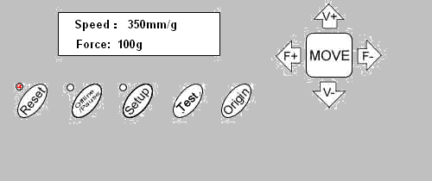
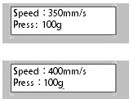

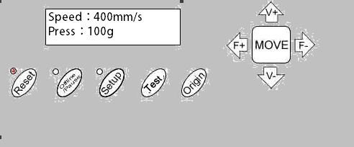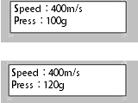

4-5.3 Offline /Pause
Press the OFFLINE key to enter offline mode. The yellow light is on. Meanwhile, “Motion, X= xxx, Y= yyy” will appear on LCD, which shows the coordinates location of the blade at the moment.

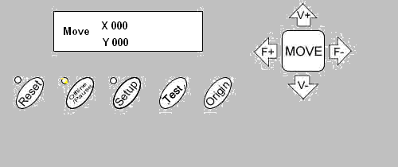

Press the key V+ or V- the carriage can be moved left or right. Press the key F+ or F- the vinyl can be moved forward or backward., In this state you you can move the blade top to the starting position. the step value of “X, Y” in the LCD will change accordingly




When it is working you press the Pause Key , the machine will stop working and if you press again the machine will cantinue working

4-5.4 Setting origin of plotting
When move the blade top to the starting position , press the Origin button the setting of the new origin is completed , The machine will start plotting from the new origin.
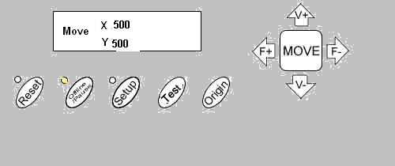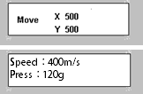
4-5.5 Setup
In ONLINE status, when you press the SETUP key, the green light is on, and the baud rate of serial port can be changed. If you press SETUP key again, it will restore to online status.

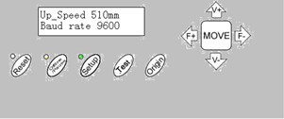

Caution:
Unless professional technicians, you’re not suggested to change this setting.
If something unusual accurs and you are unable to stop the cutter, turn the power off or unplug it
4-5.6 After work is over
After work is over…
1.Remove the paper.
2.Remove the cutter holder or plotter holder, then wipe it clean with a soft-cloth and keep it properly.
3.Turn off the power, and pull the power cord out if not using during a long time.
4.Cover the machine with a cloth or a cover.

Chap. 5 Parameters Table
Technical Specifications
Model | 361 | 721 | 871 | 1101 | 1351
Max. paper width | 365mm | 720mm | 870mm | 1100mm | 1350mm
Max. cutting width | 275mm | 630mm | 780mm | 1010mm | 1260mm
Cutting speed | 10-1000mm/s
Cutting press | 10-600g
Buffer capacity | 4M
LCD | YES  Optional  Optional  Optional
CPU | 16-bit CPU
Strip of plotter | Plastic sheet
Drive | Stepping
Min. character matrix | Approx 5 mm [0.2''] high
Blade type | Super steel [1.2mm and 2.0mm]
Film type | Self -adhesive vinyl film, fluorescent film, reflective film, paper
Display panel | 8digits X 2 line LCD
Interfaces | Serial & USB port
Power requirements | 90-260V
Repeatability | 0.0125mm
Mechanical resolution | 0.0254mm/step
Commands set | DMPL / HPGL
Environmental temperature | 0-35℃
Environmental humidity | 5%-65%（without condensation）

Chap. 6 USB Port Setting
USCutter USB Driver setting
6-1. Install USB port(USCut USB Driver):
Connect USB cable with USB port of your computer and insert Driver CD into your CD ROM of computer. You will find the following installation guide, choose as following and press “Next” and enter USB installation.
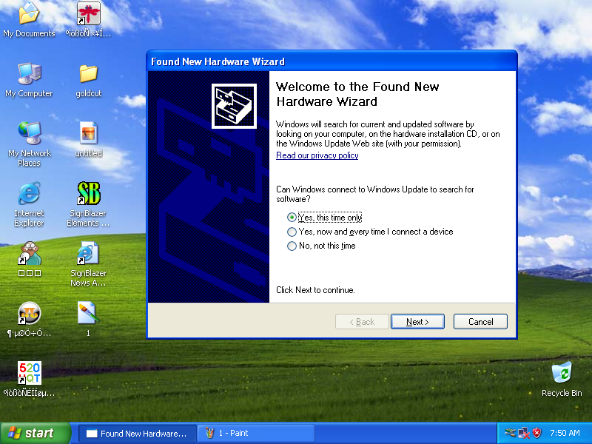
Then choose as following and press: Next”
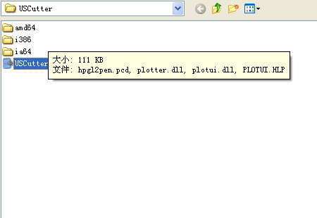
Then press “Finish”
6-2 Port Setting:
Open “Printers and Faxes”, you will find “ USCut Series” click the right mouse of it and then choose as following, press” OK”


6-3. Software
6-3.1 Artcut software
Open Artcut software, and click”Cut/plot”, then choose “USB 001”port from “Link to”
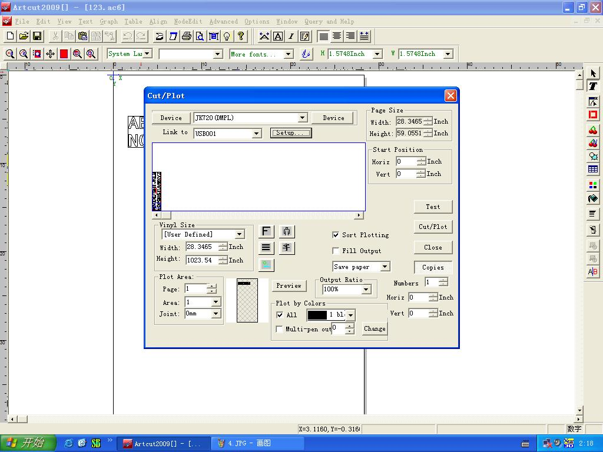
Click”setting “to open “ Port setting “ and then click “ Parameter “ open “Com Setting “
Choose 9600 for “ Baud Rate” and choose “ XON/ X OFF RTS/CTS” in Sequential Comtrol
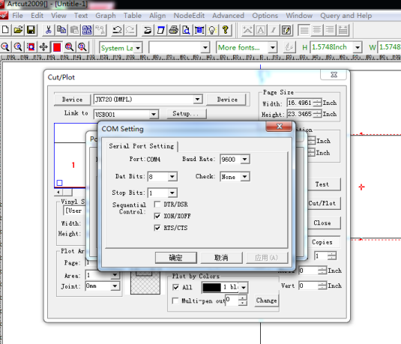
Then finish and the file is sent to machine as following
Then please check whether there is “USB Printing Support” in Device manager, If it is there, that is OK
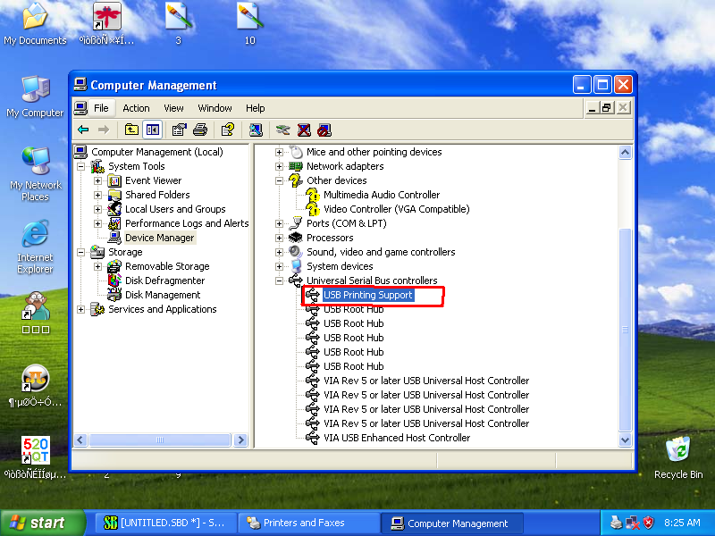

6-3.2 SignBlazer software
Open SignBlazer software, press “Cut” menu, set the parameter as following, press “ OK” 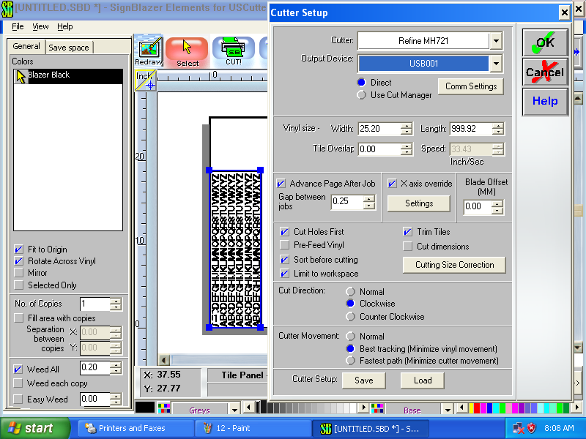

Then press “ Setup” menu, set the parameter as following

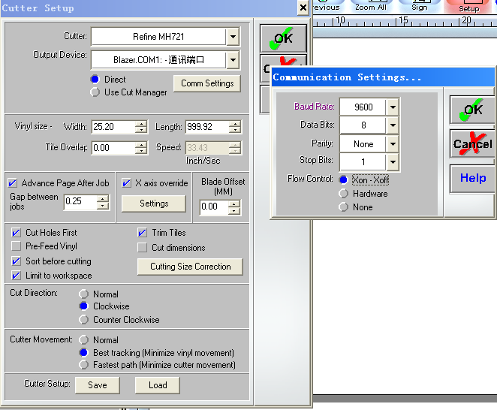

Then finish and the file is sent to machine as following
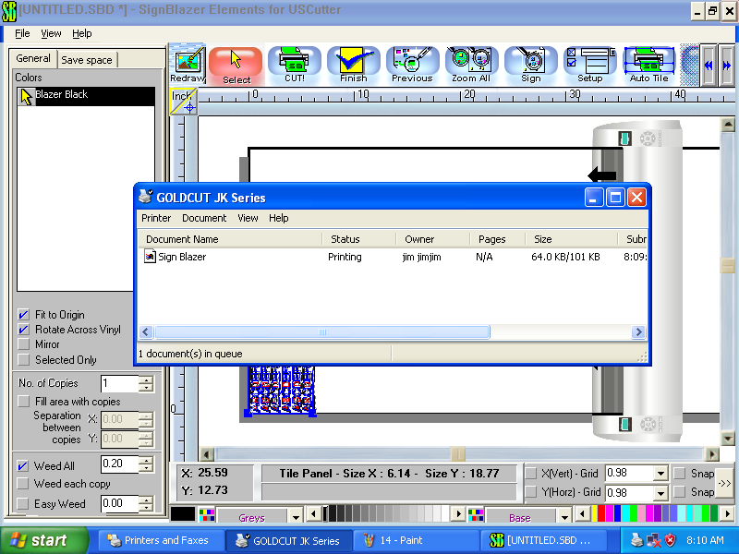
Then please check whether there is “USB Printing Support” in Device manager, If it is there, that is OK
6-3.3 CorelDraw software
Select your graph, and then click "Outline" and choose "Hairline".
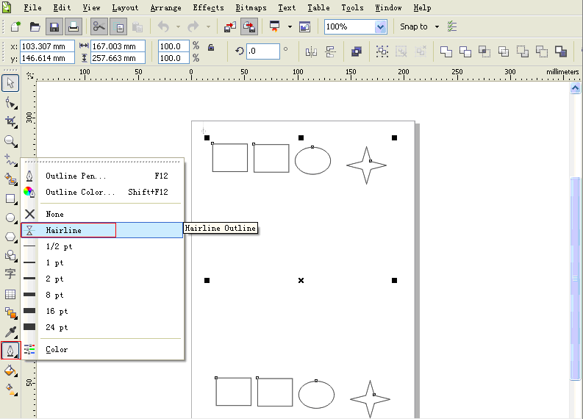

Then "Fill", choose "None".
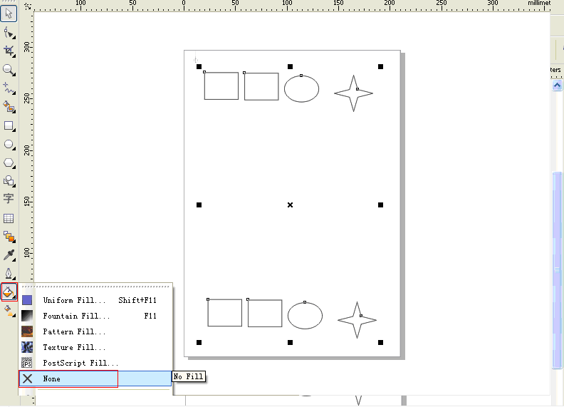
Click " Print" and choose "GOLDCUT JK series" as your printer.
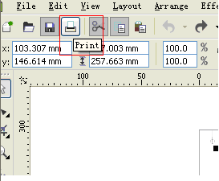

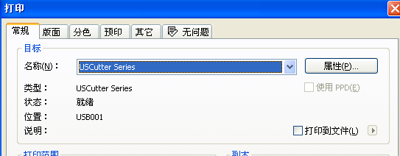
In a printer attributes adjustment version size
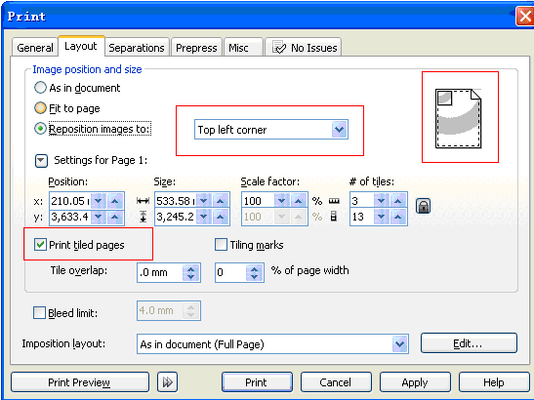
Chap. 7 Troubleshooting
Why is the pattern deformed or incomplete?
- More pressure or too long blade tip or too dirty platen or too soft stickiness, all of these factors can cause more resistance to the two faces of paper and make it fall behind the roller rotating, thus result in deformed pattern.
- The software setting isn’t proper. (The tool compensation value is too big)
- The carriage belt is too loose, or the metal roller can’t exactly follow the motor running.
- The motor doesn’t run all the steps.
- The pattern is normal but not complete, this may be resulted from too small tool compensation value.
Why does the machine plot abnormally?
- Software setting is not matched to the machine, so you must adopt proper commands set or set proper tool compensation value.
- The plotting software is suddenly broken up.
- Plotting software has been damaged or there is virus in computer.
Why does the paper run deviation?
- The stickiness isn’t placed right.
- The platen is too dirty so that the resistance from two sides can’t be balanced when the paper is moving.
- The pinch rollers have been deformed or don’t match to each other.
- The pressure of the pinch roller is a little smaller and the paper is very sensitive to the external press.
- The balance of the stickiness weight isn’t very good.
Why some parts of letters are missing?
- The vinyl is too heavy or too tightly wrapped. Metal roller might be soiled by some foreign substance or by vinyl chips.
- Cutting speed is too fast, cutting press is too great, or cutter tip is too long.
- Synchromesh belt is too tight, or pinch roller is under too much pressure.
- Metal roller is faulty. Contact local distributor for repairs and replacement.
Why different letters on the same line are cut to different depths?
- Cutter holder is not tightly attached. It should be tightened.
- Cutter blade is not tightly set in the holder.
Why letters appear to have ripples?
- Cutting speed is too fast. Except for cutting large letters, speed should not exceed 480mm/s.
- Cutting blade is of poor quality, or it has been damaged. Replace it.
- Cutter holder is not tightly installed. Tighten screw.
Cutting small letters
When cutting small letters, cutting speed and press should be adjusted to the lowest setting. Similarly cutter tip should be adjusted to as short as possible.
Cutting large letters
Cutting speed and press may be increased to higher settings. When cutting large letters Sharp Angle in Artcut software may be ignored.

